

**DOCUTRACKER: A WEB BASED DOCUMENT MANAGEMENT INFORMATION SYSTEM FOR DAVAO ORIENTAL STATE UNIVERSITY**

**Ivan Dawang**

**Patrick Gerald Heyres**

**Cleo Khaye Marie Marohom**

**A BSIT Capstone Project Submitted to the Faculty of Computing, Data Sciences, Engineering, and Technology of the Davao Oriental State University in Partial Fulfillment of the Requirements for the Degree**

**BACHELOR OF SCIENCE IN INFORMATION TECHNOLOGY**

**MAY 2024**

Republic of the Philippines

**DAVAO ORIENTAL STATE UNIVERSITY**

**Faculty of Computing, Data Science, Engineering, and Technology**

Guang-guang, Dahican, 8200, City of Mati, Davao Oriental

**ACADEMIC INTEGRITY DECLARATION**

We, **IVAN P. DAWANG**, **PATRICK GERALD W. HEYRES**,and **CLEO KHAYE MARIE E. MAROHOM,** declare that this Capstone/Thesis is our original work. Most stipulations are presented herein and ours alone. Borrowed ideas are given due recognition and are appropriately acknowledged. To the best of my ability, this investigation was treated with utmost care to adhere to internationally known standards/policies on academic integrity.

We attest further that this piece of academic requirements has not been submitted previously for an academic credit in this or any other courses.

**IVAN P. DAWANG**

Researcher/Author

Date: _____________________

**CLEO KHAYE MARIE E. MAROHOM**

Researcher/Author

Date: _____________________

**PATRICK GERALD W. HEYRES**

Researcher/Author

Date: _____________________

**FEBRUARY 2024**

**ACKNOWLEDGEMENT**

We would like to take this opportunity to thank **Mr. Ar-jay R. Sacay**, our respected advisor, for his solid support, wisdom, and assistance during the course of this project. His broad expertise, priceless ideas, and commitment to our academic growth have been crucial in determining the course and results of our study. We are very appreciative of his guidance and all the time he has spent giving us advice and support.

We also sincerely thank **Mr. Dony C. Dongiapon**, the chairman of our panel, for his significant efforts and guidance during the review process. His clear insights, intelligent criticisms, and clear suggestions have significantly improved the quality of our work. We also want to express our gratitude to **Ms. Cindy A. Lasco** and **Ms. April Joy B. Uy**, our panel member. Their knowledge, considerate criticism, and careful assessment were extremely helpful in guiding the development and enhancing the validity of this study. Also, we would like to express our deepest appreciation and gratitude to our coordinator for their invaluable assistance and unwavering support in helping us fulfill our needs. We are incredibly grateful for their efforts, time, and important contributions to our study.

Furthermore, we wish to express our sincere gratitude to all of our friends, coworkers, and family members who have helped us along the way. Our ability to overcome the difficulties we faced has been greatly aided by their support, patience, and understanding. We endured and accomplished our objectives because of their solid trust in our ability.

The Researchers

**TABLE OF CONTENTS**

**TITLE PAGE**

**CHAPTER I INTRODUCTION**

1.1 Rationale of the Study…………………..…………………………………………………..1

1.2 Purpose and Project Description…………………………………………………………..3

1.3 Objectives of the Study……………………………………………………………………..3

1.4 Significance of the Study…………………………………………………………………...4

1.5 Scope and Limitation………………………………………………………………………..5

1.5.1 Scope………….………………………………………………………………….5

1.5.2 Limitation…….…………………………………………………………………...6

1.6 Conceptual Framework……………………………………………………………………..6

1.7 Definition of Terms…………………………………………………………………………..7

**CHAPTER II REVIEW OF RELATED LITERATURE**

2.1 Technical Background……………………………………………………….…………...…8

2.1.1 Svelte…….…………………………………………………………..……...……8

2.1.2 MySQL……...……………………………………………………………….…...9

2.1.3 Flask……………..………………………………………………………………10

2.2 Related Literature………………………………………………………………………….10

2.3 Related Systems……………………………………………………………….…………..14

2.3.1 University of the Philippines Document Tracking System…….…………..14

2.3.2 M-Files: Digital Document Management……….……………………………15

2.3.3 Globodox Document Management Software…..…………………………...16

2.3.4 Folderit Cloud Document Management System………..…..……………..17

2.3.5 Gigatrak Document Tracking System………………..………..…………….18

2.4 Synthesis……………………………………………………………………………………19

**CHAPTER III MATERIALS AND METHODS**

3.1 Software Methodology…………………………………………………………………….21

3.2 Requirements Analysis…..………………………………………………………………..23

3.3 Requirements Documentation…...……………………………………………………….23

3.3.1 System Architecture………………………………………….………………..23

3.4 Requirements Specifications……………………………………………………………..24

3.4.1 Product Perspective..…………….……………………………………………24

3.4.2 Product Features……………………………………………………………….25

3.4.3 User Class and Characteristics….…………………………………………...25

3.4.4 Opening Environments……………..………………………………………….26

3.4.5 Design and Implementation Constraints…….………………………………26

3.4.6 Other Non-Functional Requirements…….…………………………………..26

3.4.7 Software Quality Requirements…………………..…………………………..28

3.5 Design……………………………………………………………………………………….32

3.5.1 Use Case Diagram………………………………..……………………………32

3.5.2 Entity Relationship Diagram……………………..……………………………35

3.5.3 Data Dictionary………..………………………………………………………..36

3.5.4 Graphical User Interface Design…….……………………………………….40

3.6 Development and Testing………………………………………………………………...47

3.6.1 Development…………………….……………………………………………...47

3.6.2 Data Analysis Plan……………………..………………………………………47

**CHAPTER IV RESULT AND DISCUSSION**

4.1 Achievement per Objective……………………………………………………………….49

4.2 Implication and Result Discussion ……………………………………………………..52

4.3 Implementation Plan……………………………………………………………………….53

**CHAPTER V SUMMARY, CONCLUSION, AND RECOMMENDATION**

5.1 Summary……………………………………………………………………………………54

5.2 Conclusion………………………………………………………………………………….54

5.3 Recommendation……………………….………………………………………………….55

**LITERATURE CITED…………………………….…...……………………………………….56**

**CHAPTER I**

**INTRODUCTION**

**1.1 Rationale of the Study**

In today's business environment, one of the most prevalent challenges faced by organizations is the loss of physical documents. It's estimated that 75% of all 12 corporate documents are misplaced and remain undiscovered. The time and resources spent on searching for lost documents and the cost of replacing them can be significant. Document loss can lead to wasted time and resources, as well as potential legal and financial implications (Bentech, 2022). This issue is also relevant to Davao Oriental State University (DORSU).

Not having a document management system can make it challenging to find documents and understand their status. This may result in wasted time and effort as employees spend hours sifting through physical files only to discover that the document is missing or overlooked. Additionally, the lack of clarity in document status can lead to potential errors in document approval, as stakeholders may not have access to the most up-to-date version or may be unaware of changes made to the document. Furthermore, the absence of a document tracking system can contribute to compliance issues due to missing or outdated documents, potentially leading to fines, penalties, or legal action. For organizations subject to strict regulatory requirements or industry standards, accurate and timely document management is essential for compliance and avoiding legal consequences.

Implementing a document management system can help prevent these problems by providing features such as document metadata, search functionality, status tracking, etc. This ensures that documents are easily accessible, and securely managed throughout their lifecycle.

DOCUTRACKER is an advanced web-based document tracking system that provides DORSU with a seamless tracking solution. This innovative system has the potential to significantly reduce the time and effort involved in locating documents, as well as ensuring awareness of their whereabouts, and guaranteeing efficient and secure tracking. By implementing a document tracking system like DOCUTRACKER, businesses can experience improved efficiency, enhanced security, and a reduction in errors and misplaced documents. Ultimately, this can lead to better collaboration and streamlined document routing, resulting in cost savings (Q. Techopedia, n.d. 2019).

A recent global study on document tracking highlights Publuu Interactive Online Flipbook. Publuu is a cloud-based platform designed for modern businesses, allowing them to create, organize, and monitor all their business documents in one place using Flipbook PDFs. It stands out as a real-time document tracking system that allows users to share multiple trackable links for each recipient or group they want to monitor. This feature sets Publuu apart from other document tracking technologies currently available (MD. Carolina Monntoya, 2023).

The Department of Social Welfare and Development Field Office V is implementing a web-based electronic document tracking management system to streamline document transactions. The system, which includes identifying, classifying, storing, securing, retrieving, tracking, and preserving documents, is designed to improve communication between clients and staff. It enhances document tracking, and make information more accessible. The system is fully functional and is expected to improve the processes of the DSWD Field Office V, enhancing overall efficiency and effectiveness. (K. Smith Shoen, 2016)

DOCUTRACKER is driven by the need for an efficient and organized document management system within the university. The current manual document tracking processes at DOrSU are prone to errors, delays, and inefficiencies, leading to challenges in maintaining accurate records and ensuring timely access to information. The implementation of DOCUTRACKER aims to address these issues by leveraging web-based technology to streamline document tracking, enhance collaboration among university departments, and improve overall administrative efficiency. The system is designed to automate document creation, tracking, and retrieval, providing a centralized platform for users to monitor the status of documents in real time. The study seeks to evaluate the impact of DOCUTRACKER on reducing administrative bottlenecks, enhancing workflow efficiency, and ultimately contributing to the overall effectiveness of document management at Davao Oriental State University.

**1.2 Purpose and Project Description**

The purpose of this project is to provide Davao Oriental State University (DOrSU) with a comprehensive document management information system that tracks documents to simplify the process and boosts the overall workflow.

**1.3 Objectives of the Study**

The main objectives of the project are to develop, and design a web application that allows users to track the whereabouts of their documents and to notify the users as well, which aimed to:

1. To design and develop a system that is capable of:

* Using a QR Generator to generate code when registering a document;
* Providing a document real-time status reporting for under-going documents;
* Providing a total lifecycle time of document when completed as well as calculates and visualize the time taken of each route, and;
* Providing downloadable data for offline access of reports;

1. Asses the **DOCUTRACKER: A Web Based Document Management Information System for Davao Oriental State University** to determine if it complies with IEEE 25010
2. Craft an Implementation Plan for the rollout of the **DOCUTRACKER: A Web Based Document Management Information System for Davao Oriental State University**

**1.4 Significance of the Study**

This paper seeks to create a web-based platform document information management system to prevent document loss and streamline document processing.

The collected data will provide valuable insights into the challenges, issues, and their solutions, serving as a resource for future researchers to enhance their understanding, expand their knowledge, and develop more effective solutions for the benefit of all.

**1.5 Scope and Limitation**

* + 1. **Scope**
* The document management information system has its main features which are the Manage registered accounts, manage documents and view document status for admin interface, while the Register Document, View Document Status and User’s profile is for user’s interface and the Document register approval and view document status for receiver’s interface.
* The main focus of the system is in every faculty in Davao Oriental State University (DorSU) that includes the following which is the Faculty of Computing, Data Sciences, Engineering and Technology (FCDSET), Faculty of Nursing and Allied Health Science (FNAHS), Faculty of Teacher Education (FTED), Faculty of Agriculture and Life Sciences (FALS), and Faculty of Governance, Business and Management (FGBM).
* The process of document tracking has its different processes and receiver flow in every document. There are some documents that are from faculty, and there is a document that is outside of faculty process.
* For the process of “Faculty Loading”, it will undergo to program head, Dean and to the academic VP.
* For the process of “Requested Subject”, it will undergo to program head, dean, and to the VP.
* For the process of “Endorsement Form”, it will undergo to communication, faculty program head, faculty dean, VP, and to the OP, once it is done, it will be approved.

**1.5.2 Limitation**

* This system will be implemented only at Davao Oriental State University main campus.
* The system only tracks selected documents, (Faculty Loading, Requested Subject, Endorsement Form).
* Only the selected users can use DOCUTRACKER, (Program Head, Dean Office, Academic VP, OP, Secretary).
* The system needs internet connection in order to be accessible.

**1.6 Conceptual Framework**

**INPUT**

**Knowledge Requirements:**

* Tacit knowledge
* Organizational knowledge
* Knowledge gaps

**Software Requirements:**

* Svelte
* Flask
* MySQL

**Hardware Requirements:**

* Desktop (PC)
* Laptop

**OUTPUT**

DOCUTRACKER: A Web Based Document Management Information System for Davao Oriental State University

**PROCESS**

**Requirement Gathering and Analysis**

* Planning
* Design
* Development
* Testing
* Evaluation

Figure 1.1: Conceptual Framework

**1.7 Definition of Terms**

**User Requirement/Specification:** The user requirement document or user requirement specification is a document usually used in software engineering that specifies what the user expects the software to be able to do.

**Data Collection/Gathering:** is the process of gathering and measuring information on targeted variables in an established system, which then enables one to answer relevant questions and evaluate outcomes.

**Requirement Gathering and Analysis:** is a process used to determine the needs and expectations of a new product. It involves frequent communication with the stakeholders and end-users of the product to define expectations, resolve conflicts, and document all the key requirements.

**CHAPTER II**

**REVIEW OF RELATED LITERATURE**

* 1. **Technical Background**

To develop the DOCUTRACKER system, a Web-Based Document Management Information System for Davao Oriental State University, the researchers have identified the programming languages and libraries that will be utilized, as outlined below:

* + 1. **Svelte**

Svelte is an innovative tool for creating interactive User Interfaces (UI). Unlike traditional JavaScript libraries that perform most of their work in the browser, Svelte moves this process into a compilation step that occurs during app building. This leads to highly efficient code that updates the Document Object Model (DOM) with incredible speed. Svelte functions as a compiler, so it's not as simple as adding a script tag to your page and importing it into your app. You'll need to configure your development environment to allow the compiler to perform its tasks. Components serve as the foundational elements of Svelte applications. They are authored in. svelte files using an extended version of HTML. The Svelte compiler transforms your components into JavaScript to render the HTML for the page and into CSS to style the page.

In DOCUTRACKER, Svelte is the chosen tool for developing the application's user interface. Svelte is a front-end library specifically designed for creating interactive user interfaces that run in a web browser. Unlike other libraries, Svelte does not rely on a virtual DOM. Instead, it compiles code into optimized vanilla JavaScript, which reduces runtime overhead and enhances application performance (Nakajima, 2021).

Svelte components, which are written into svelte files using a superset of HTML, are the building blocks of Svelte applications (Anonymous, 2016). These components encompass the logic, style, and markup of a part of the user interface. For instance, in a DOCUTRACKER, there might be Svelte components for displaying a list of documents, a detailed view of a selected document, a form for creating new documents, and so on.

* + 1. **MySQL**

MySQL, an acronym for "My Structured Query Language," is an open-source relational database management system (RDBMS) renowned for its efficiency and versatility. Developed by MySQL AB and now owned by Oracle Corporation, it forms an integral part of the widely adopted LAMP stack, alongside Linux, Apache, and PHP/Python/Perl. Operating across various platforms such as Linux, Windows, and macOS, MySQL organizes data into structured tables with rows and columns, facilitating efficient management and retrieval of information.

With its robust performance, scalability options, and advanced security features, MySQL is a popular choice for diverse applications, ranging from web development to data-driven software solutions. Its open-source nature fosters an active community of developers, contributing to ongoing improvements and support. MySQL's ability to handle large datasets, execute complex queries swiftly, and seamlessly integrate into various environments underscores its significance as a reliable and widely used relational database management system in the realm of modern computing.

**2.1.3 Flask**

Flask is a small and lightweight Python web framework that provides useful tools and features that make creating web applications in Python easier. It gives developers flexibility and is a more accessible framework for new developers since you can build a web application quickly using only a single Python file. Flask is also extensible and doesn’t force a particular directory structure or require complicated boilerplate code before getting started. Flask takes a radically different approach to creating web apps. It’s a micro framework, equipped only with the web app development essentials. Its strength lies in its customizability. The flask is flexible, allowing you to experiment and switch directions easily.

DOCUTRACKER used Flask for the backend to handle data manipulation, authentication/validation, database integration, and other server-side operations.

**2.2 Related Literature**

The research paper titled "A Data Centre Configurable Data Mining Document Management Information System, 2021" by Gurusubramani, S., Mouleeswaran, S. K., Srinivas, P., & Aruna, R., highlights the rapid growth of electronic information across various human activities, including research and industry, over the past two years. The paper emphasizes the generation of large data sets from cameras, instruments, handheld devices, and computers, necessitating efficient technologies for flexible data collection workflows, particularly through cloud-based storage platforms. It delves into the implementation of cloud infrastructure to create an optimized framework for scalable data analysis workflows. The authors explain the construction and application of the Data Mining Cloud Architecture, along with a data analytics method that integrates visual workflow vocabulary within a Virtualized environment. The DMCF (Data Mining Cloud Framework) aims to streamline the development of data mining applications by integrating them with generic system monitoring schemes, offering a solution tailored to actual data mining requirements.

The research paper titled "Electronic Document Management Information System for Universities, 2018" authored by Costoiu M., Plesu V., Isopescu R., Soriga S., Alesincu S., Arsene I., underscores the importance of efficient fund administration and cohesive coordination of various activities in the management of Higher Education institutions. This study highlights the continuous improvement of the electronic document management information system within the University, aiming to provide an effective management tool. A comprehensive assessment was conducted to address the myriad documents circulating within the University and the challenges associated with the digitization of certain essential documents. Additionally, the authors noted that the document management system allows for document creation by authors, as well as document input through scanning, automatic import from file systems or other applications, via email, or through automatic generation based on forms.

The study titled "Interrelationship between document management, information management, and knowledge management, 2017" by N. Sewdass asserts that documents are naturally produced as a result of organizational activities. Information and knowledge are considered crucial assets for organizations. Effectively managing documents, information, and knowledge can enhance business efficiency and effectiveness, contributing to organizational competitiveness. These three concepts—document management, information management, and knowledge management—are increasingly prominent in academic and vocational literature. Despite the frequent use and discussion of these concepts, there is still ambiguity, confusion, and little consensus on how to execute them.

The study "System Development for Document Management System, 2018," authored by Kiplie, Yatin, Angutim, and Hamid, emphasizes that digitization systems should consistently facilitate the sharing and movement of data from other systems, irrespective of the chosen integration level. System development entails a formal series of processes to define, design, test, and implement new software applications or programs, including customizing systems internally and creating database systems. A digitization system enables organizations to capture crucial materials that can be leveraged as valuable information and knowledge for business, academic, or research purposes. According to Kroenke (2015), an information system is an organized framework for collecting, organizing, storing, and communicating information. Specifically, it involves a network of connected individuals and organizations that gather, filter, process, create, and distribute data to specific users. Therefore, an information system can be defined as a set of interconnected components working together to generate, present, and disseminate information.

The study titled "Electronic Document Management System: Malaysian Experience, 2021" by Yatin, S. F. M., Ramli, A. A. M., Shuhaimi, H., & Kadir, M. R. A., discusses the long-advertised benefits of document management systems in solving paper-related issues. These systems offer the potential to tightly control the handling of paper documents and are sometimes referred to as "enterprise or electronic document management systems." It's crucial to understand that these systems manage documents, not the information or knowledge within them. Therefore, their impact on a business lies in the efficiency they provide in document storage, retrieval, and information access.

The study also highlights the increasing acquisition of computers for record keeping as the awareness of computers as a tool for data processing grew. An initiative in Vision 2020 focuses on record keeping and document management, specifically the Generic Office Environment-Electronic Government Document Management System (GOE-EGDMS). The study aims to evaluate the usage and effectiveness of the GOE-EGDMS implementation using the IS Effectiveness Model from DeLone and McLean.

A study titled "eGovernment Document Management System: A Case Analysis of Risk and Reward, 2016" by Jones, S, emphasizes the significance of deploying an electronic document management system (EDMS) to establish a virtual workplace environment and enhance the capabilities of a modern organization and its workforce (Adam, 2007). The study points out that EDMS can empower users to streamline business processes through workflow and information sharing, ultimately improving information management (Hammer & Hershman, 2010). Additionally, Read (2009) underscores that using IT in back-office functions can significantly enhance operational efficiency, particularly with EDMS implementations (Wilkins, Swatman, & Holt, 2009). There is also a growing acknowledgment that common IT systems and business processes in the public sector can lead to efficiencies (Gershon, 2004). As the public sector increasingly adopts technology and seeks to be more innovative, organizations are turning to IT systems to transform service delivery both internally and externally. This case analysis delves into the initiation and implementation of the EDMS and leverages literature and case study findings to propose a framework for assessing the value, benefits, and risks of an electronic document management system, ensuring that it aligns with desired outcomes.

**2.3 Related Systems**

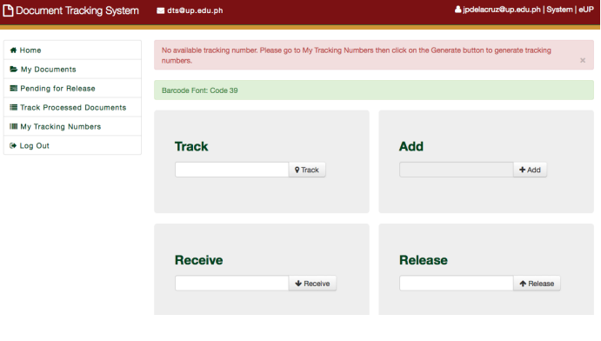**2.3.1 THE UNIVERSITY OF THE PHILIPPINES DOCUMENT TRACKING SYSTEM**

Figure 2.1 University of the Philippines Document Tracking System Interface (UPITDC, 2022)

The Document Tracking System (DTS) at the University of the Philippines (UP) is an information system designed to monitor the flow of paper documents across UP offices. It captures details such as the origin and destination offices, personnel involved, and the time taken for documents to move between offices, units, or departments. The DTS also provides support for document attachments, revisions, updates, and remarks, enhancing its functionality and usability.

In today's rapidly advancing technological landscape and the growing importance of efficient information management, the emergence of document tracking systems has provided a solution to enhance the accessibility of documents online, whenever needed. Given the common tendency of document workers to lose track of document paths, it is imperative for these systems to effectively trace the movement of documents from their origin to their intended destinations. Although some corporate and educational institutions may believe that transitioning from paper-based processes is unnecessary, the significance of adopting such practices has never been more critical. However, determining the appropriate timing and method for transitioning from paper to digital documents can be a challenging task.

**2.3.2 M-FILES: DIGITAL DOCUMENT MANAGEMENT**

Figure 2.2 M-Files: Digital Document Management Interface (M-FILES, 2018)

The next-generation intelligent information management platform M-Files provides answers to all the problems associated with managing digital documents. M-Files offers a fundamentally different approach to document management in addition to a set of effective enterprise content management technologies, completely altering how businesses organize information. M-Files prioritizes metadata labeling to make documents easy to identify, find, and incorporate into operations rather than classifying them based on where they are stored. A document's metadata can include everything from the name of a client or project to the person who developed it, the format of the information it contains, the people who need to see it and in what sequence, invoice and project numbers, due dates, and any other information. (M-Files, 2021)

**2.3.3 GLOBODOX DOCUMENT MANAGEMENT SOFTWARE**

Figure 2.3 Globodox Document Management Software Interface (GLOBODOX, 2023)

GLOBODOX offers comprehensive document management solutions designed to help you efficiently organize, manage, and share critical business information. It is suitable for organizations of all sizes and comes with modules for workflow, document retention policy, customer portal, and more. GLOBODOX DMS is user-friendly, easy to install, and can be configured to meet specific business needs. With its affordability and versatility, GLOBODOX is widely utilized by SMBs and large enterprises across various industries such as Government, Banking, Financial Services, Insurance, Healthcare, Legal, Education, Service, Manufacturing, Technology, Real Estate, and Consultancy. The system features integrated tools for document scanning, indexing, searching, securing, sharing, and maintaining an audit trail. Additionally, GLOBODOX's workflow capabilities enable electronic document routing to streamline and automate business processes.

**2.3.4 FOLDERIT CLOUD DOCUMENT MANAGEMENT SYSTEM**

Figure 2.4 Folderit Cloud Document Management System Interface (FOLDERIT, 2023)

Folderit provides an easy to use document management system software where you can store, manage, share, and gain better control of all digital documents. But don’t take just our own word for it — Folderit was named the most user-friendly document management system in the world! Folderit provides a secure offsite cloud-based DMS to keep your important data safe from risks of fire, hardware failure, criminals, floods and other natural disasters. It’s the best DMS for both small and medium businesses.

**2.3.5 GIGATRAK DOCUMENT TRACKING SYSTEM**

Figure 2.5 Gigatrak Document Tracking System (Gigatrak, 2018)

The GigaTrak Document Tracking System offers a versatile solution for organizations requiring efficient document and material tracking. By utilizing barcodes to identify employees, locations, and materials, this system ensures both accuracy and cost-effectiveness. Users can simply scan employee or location barcodes using a handheld Android device, and then assign a barcode to each document. This allows for quick retrieval of documents, with a comprehensive chain of custody report available. The system is easy to implement and can make use of existing cell phone cameras for individual barcode scans or a dedicated Android PDA with an integrated barcode scanner for rapid scanning of multiple documents.

The GigaTrak Document Tracking System simplifies the process of tracking the whereabouts of documents and materials, providing organizations with a quick and easy solution. In every organization, the need to track documents and materials until they are no longer required is a crucial aspect of efficient operations.

**2.4 Synthesis**

DOCUTRACKER is a web-based Document Management Information System developed as a capstone project for Davao Oriental State University. It addresses the university's need for an efficient document management system that can handle both physical and electronic documents. The system will be developed through a comprehensive needs analysis involving surveys, interviews, and focus groups, which identified the university's specific requirements and challenges in document management.

This system, namely “DOCUTRACKER” will be built with Svelte and Flask, that offers tracking services and a user-friendly interface. It utilizes MySQL to securely store, manage, and maintain all university documents. Advanced search capabilities and tagging systems allow users to quickly retrieve needed document data.

The related literature of the study emphasizes the relevance and importance of document management information systems and how they can be helpful in every organization. Based on these articles, different perspectives and objectives emerge regarding the assessment of document tracking systems, even though they share the same intention for implementing document tracking.

Implementing a Document Tracking System can make it simple for DORSU to keep track of all its documents where the system's main goal is to provide secure tracking of documents. The system's user-friendly interface may minimize the need for extensive training or technical support, further streamlining the document management process.

|  |  |  |  |  |  |  |
| --- | --- | --- | --- | --- | --- | --- |
| Features | Proposed study | Existing Document Management System/Document Tracking System | | | | |
| DOCUTRACKER: Web Based Document Management Information System | The University of the Philippines Document Tracking System | M-FILES Digital Document Management | GLODOBOX  Document Management Software | FOLDERIT  Cloud Document Management System | GIGATRAK  Document Tracking System |
| Web based platform | YES | YES | NO | NO | YES | NO |
| Request Document | YES | YES | YES | NO | NO | NO |
| View Request Status | YES | YES | NO | NO | NO | NO |
| Able to track document request by entering track code | YES | YES | NO | NO | NO | YES |
| Able to generate QR with tracking code | YES | YES | NO | NO | NO | NO |

Table 2.1: Tabulated Comparison of the System’s Feature

**CHAPTER III**

**MATERIALS AND METHODS**

**3.1 Software Methodology**

The system is built using the Agile methodology, a collaborative and iterative approach to software development that emphasizes user input, cooperation, and continual improvement. Although initially designed for software development, the concepts of Agile are now employed across various disciplines and sectors. Key concepts include incremental delivery, cross-functional teams, face-to-face communication, functional software over documentation, self-organizing teams, regular reflection and improvement, and transparency.

Incorporating the Agile methodology into DOCUTRACKER can lead to enhanced transparency, swifter value delivery, increased user satisfaction, and the ability to efficiently adapt to changing requirements. Agile methodology provides a structured approach to developing efficient and adaptable tracking management systems by embracing iterative development, visual tracking, continuous feedback, and empowered teams.

Figure 3.1. Agile Methodology Model (MEDIUM, 2020)

**Requirements:**

In this process, the researchers built a plan for how the document information management system would be developed. This was accomplished by defining the purpose and goal of the system and determining and documenting the user requirements and system needs.

**Design:**

In this process, the researchers constructed and finalized the design of the system and the user interface. This was achieved by using a prototype and wireframing tools for the implementation of the design.

**Development:**

In this process, the proposed system was developed based on the plans made by the researchers. It was done by using a programming language for the back end of the system, and the design was constructed through a prototype for the front end of the system.

**Testing:**

Once the development of the system is done, it undergoes a testing process in which the researchers perform tests to check for errors or mistakes in the coding and to ensure that it functions properly, meeting all the objectives outlined in the plan.

**Deployment:**

In this process, the system is ready for the deployment or implementation of the document information management system since the testing process has been completed, and this system will be implemented at DORSU. Also, the system was ready to assist the users with their documents.

**Review:**

In this process, the researchers will provide some maintenance for the future development and needs of the system. It will also be based on the feedback of the users.

* 1. **Requirements Analysis**

The researchers analyzed the requirements and information needed to ensure that the system will work perfectly and to provide services to the users, and ensures the user-friendly interface of the system. In order to develop the system, the researchers gathered the requirements needed for its development and discussed the system’s structure and design that is needed based on the information gathered.

* 1. **Requirements Documentation**
     1. 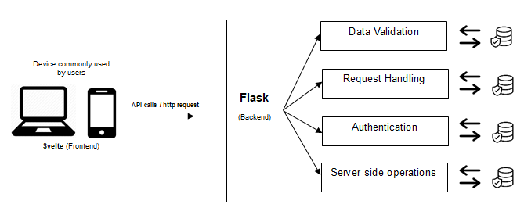**System Architecture**

Figure 3.2: Micro-Service Architecture

When the frontend needs data, it sends an HTTP request to the Flask server. The server processes this request and sends back a response, which the Svelte app then processes and uses to update the UI. This separation of concerns allows for better code organization, easier debugging, and the potential for each part to scale independently.

* 1. **Requirements Specifications**

This document management system or “DOCUTRACKER”, is a web-based system for Davao Oriental State University (DORSU), that helps the user to reduce the time of effort of processing their documents. The system is able to notify the user on the progress of their tracked and ensures the smooth flow and secure tracking of documents.

* + 1. **Product Perspective**

This web based DOCUTRACKER system allows user to add a document to be tracked whether that user is in the campus or not since it can be accessible wherever they are as long as it is connected in the internet. Once the user is done adding a document, they can be able to see the progress of the document.

* + 1. **Product Features**

DOCUTRACKER is designed to manage documents, and within the area of processing documents, the system provides information and data such as status, time visualization, etc. in which can be absorbed by the end user, the system also notifies the user about every piece of process in their document.

**User Class and Characteristics**

**3.4.2.1 User**

Users can add document in which the system can process, Users can see the status and progress of documents, Users cannot manage other user’s credentials.

**3.4.2.2 Receiver**

Receivers receives documents such as approves/rejects them and they opt for the system to process documents, the data of the process will be thrown back to the end user, they can only process documents that it is meant for them, Receiver cannot view data of documents and can't see other receiver’s processes.

**3.4.2.3 Admin**

Admin is the one who is responsible for managing the “DOCUTRACKER” system and has all the access on the user’s section, Admin manages users and receiver, it has the control over users’ data and other credentials of registered accounts.

**3.4.3 Opening Environments**

**3.4.3.1 Software Components**

The developers used “Visual studio code” for developing and designing the system. For the frontend, the developers used HTML, CSS and svelte.js library, we use several modules that comes alongside svelte to help in the overall development process of the frontend, in the backend the developers used python flask for database integration, data processing and other server side operations which exposes a rest API/endpoint which the frontend can grab into.

* + 1. **Design and Implementation Constraints**

The major implementation constraint the comes along during the development process, due to the separation of concern of the front end and backend is CORS (Cross Origin Resource Sharing), CORS is a security feature in the browser, which no frontend code can access the backend endpoint which gives the developers a hard time getting around it.

* + 1. **Other Non-functional Requirements**

The system comes with a range of Non-functional Requirements that is required and common in developing software such as Security, Usability and Availability, etc. These system attributes makes DOCUTRACKER more reliable and capable that ensures safety at the same time

**3.4.7.1 Safety requirements**

DOCUTRACKER comes with common security features that can be found in most software such as real time validation of entries, password hashing, email verification, CORS (Cross Origin Resource Sharing) ensures that only our frontend can access the backend endpoint, DOCUTRACKER uses JWT (JSON Web Tokens) to authenticate the user, admin also verifies the user accounts, etc. DOCUTRACKER ensures that the users and data are safe under its supervision.

**3.4.7.2 Security Requirements**

In order to maintain the security of the system, DOCUTRACKER is supervised by the admin which has control over the users which is called administrative Security, after users creating/signing up their account, the admin needs to verify the newly registered account first. When the user logs in for the first time and if their account is still under verification by the admin, they can’t use DOCUTRACKER which leaves them to patiently wait until their account is verified, admin also supervised users in real time this ensures that DOCUTRACKER is secure.

* + 1. **Software Quality Requirements**

The DOCUTRACKER: A Web-Based Document Management Information System for Davao Oriental offers the following features that indicate high software quality:

**3.4.8.1 Usability**

The developers will implement a user-centered design that provides a user-friendly interface that allows users and receivers to effortlessly interact within the system. The system's well-organized and visually appealing design enhances the user experience.

**3.4.8.2 Reliability**

The system is properly tested by the developers at the time of development before being implemented. It places on dependability through rigorous testing, quality assurance measures, robust error handling, and data integrity that assure constant performance and good process flow of tracking documents.

**3.4.8.3 Functionality**

DOCUTRACKER is a pioneering solution that revolutionizes the way organizations manage and track their physical documents. Unlike traditional paper-based systems that are prone to misplacement, loss, and inefficiency, your system introduces a recommended approach to document management with the precision and efficiency of digital tracking.

At its core, the system is designed to eliminate the bulk and heft of paper documents, making records easier to track and share. It addresses the critical need for updated backup copies of important documents. By digitizing the tracking process, the system ensures that every document is accounted for, reducing the risk of misplacement and enhancing the overall workflow of documents.

Moreover, the system provides detailed tracking information for each document, including actions taken, viewing document data offline, notifying, etc. This level of detail is crucial for maintaining compliance with regulatory standards. By providing a comprehensive view of document activity, the system empowers DOrSU to make informed decisions about document retention and disposal.

**3.4.8.4 Portability**

The system can be utilized across a broad spectrum of internet-connected devices, encompassing desktops, laptops, and tablets, offering flexibility and convenience for users regardless of their location. This inclusivity ensures that whether you're working from a stationary desktop setup, a portable laptop, or a versatile tablet, the system remains accessible and functional. However, it's important to note that while the system is designed for portability and ease of use across different devices, it may not be optimized for mobile phones due to the unique challenges and constraints associated with mobile platforms.

**3.4.8.5 Maintainability**

DOCUTRACKER architecture is meticulously designed to ensure high levels of maintainability, leveraging modern development practices and architectural patterns. By utilizing Svelte for the front end, you benefit from a component-based approach that significantly enhances code organization and reusability. This component tree structure not only makes the codebase easier to navigate and understand but also promotes the reuse of components across different parts of the application, reducing redundancy and simplifying maintenance efforts.

The adoption of a microservices architecture further bolsters maintainability. This approach allows for the separation of concerns, enabling the front end and back end to evolve independently. Each service within the microservices architecture can be developed, deployed, and scaled according to its specific requirements, without affecting the overall application. This modularity is crucial for maintaining the application's health and performance as it grows.

Moreover, the use of REST APIs in the backend streamlines the management of different services. RESTful services facilitate seamless communication between various components of the system, making it easier to introduce new features or update existing ones without the need for extensive modifications to the backend codebase. This modular approach to backend development simplifies maintenance tasks, as changes can be isolated to specific services, minimizing the impact on the entire system.

**3.4.8.6 Efficiency**

The system lies in its ability to provide real-time visibility into the status of documents. The system keeps track of the activities, ensuring that documents are in sight. This real-time tracking capability is particularly beneficial for businesses that undergo regular audits, as it provides a clear and verifiable trail of document activity.

The system which follows security practices are another testament to its efficiency. By controlling access to documents and ensuring that only authorized users can view and accepts them, the system protects against unauthorized access. This level of security safeguards confidential information and data associated with the document.

**3.5 Design**

**3.5.1 Use case Diagram**

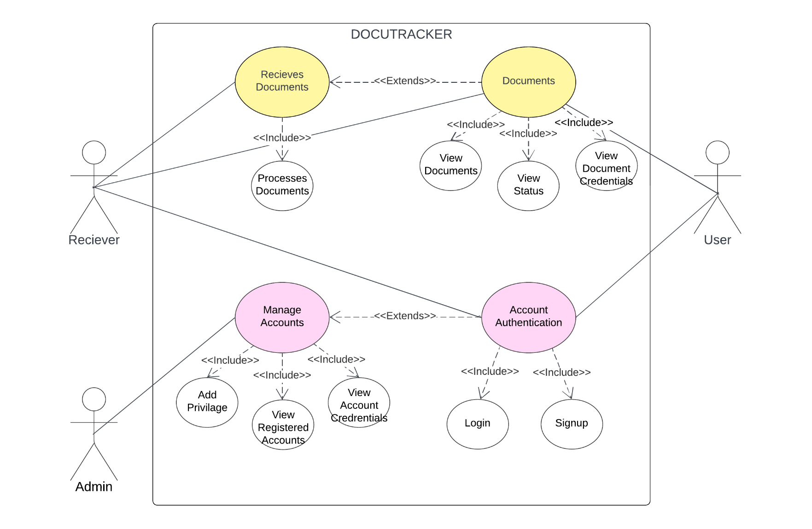

Figure 3.3: DOCUTRACKER Use Case Diagram

**3.5.1.1 Use Case Description**

The explanations of the Use Case Diagram that the developers were using were supplied in this, enabling the users to manage different aspects of the DOCUTRACKER: A Web-Based Document Management System for Davao Oriental State University.

Table 3.1: Login

|  |  |
| --- | --- |
| **DOCUTRACKER: Login** | |
| Actors | Admin/Users/Secretary |
| Description | Admin, registered user and secretary can log in their account by providing the account’s credentials like username and password. |
| Data | Users/Secretary/Admins’ username and password |
| Stimulus | By clicking the login button. |
| Response | The Dashboard page will appear. |

Table 3.2: Register

|  |  |
| --- | --- |
| **DOCUTRACKER: Register** | |
| Actors | User/Receiver |
| Description | Users and Receivers can create an account first by providing the necessary information and credentials before can get access to the system. |
| Data | User and secretary’s credentials like name, address, email, password, etc. |
| Stimulus | By clicking the “Sign–up” button. |
| Response | The login page will appear. |

Table 3.3: Add Document

|  |  |
| --- | --- |
| **DOCUTRACKER: Document Registration** | |
| Actors | User |
| Description | The users can add document for the tracking process. Users are able to add not only one, but multiple of documents. |
| Data | User’s full name, designation, id, name/type of document, description. |
| Stimulus | By clicking the “Add Document” in homepage |
| Response | The Add document page will appear. |

Table 3.4: View Request Status

|  |  |
| --- | --- |
| **DOCUTRACKER: View Document Status** | |
| Actors | Users |
| Description | The users can view the status of their requested document once they are done in adding document. |
| Data | User’s information, document status |
| Stimulus | By clicking the “Expand dropdown” in homepage |
| Response | The Document Status page will expand. |

Table 3.5: Manage Accounts

|  |  |
| --- | --- |
| **DOCUTRACKER: Manage Accounts** | |
| Actors | Admin |
| Description | The admin is able to view the list of registered account and their information. |
| Data | List of registered user and receivers accounts |
| Stimulus | By clicking an account in admin homepage |
| Response | The “Manage account modal” page will appear. |

Table 3.6: Document Approval

|  |  |
| --- | --- |
| **DOCUTRACKER: Document Approval** | |
| Actors | Receiver |
| Description | The receiver’s role is to receive the document of users. Receiver can also dismiss the document if there’s a mistake or lacking of document attachment. |
| Data | Document credentials |
| Stimulus | By clicking the “Approve button” in Document modal. |
| Response | The “Document Approval” message will appear. |

**3.5.2 Entity Relationship Diagram**

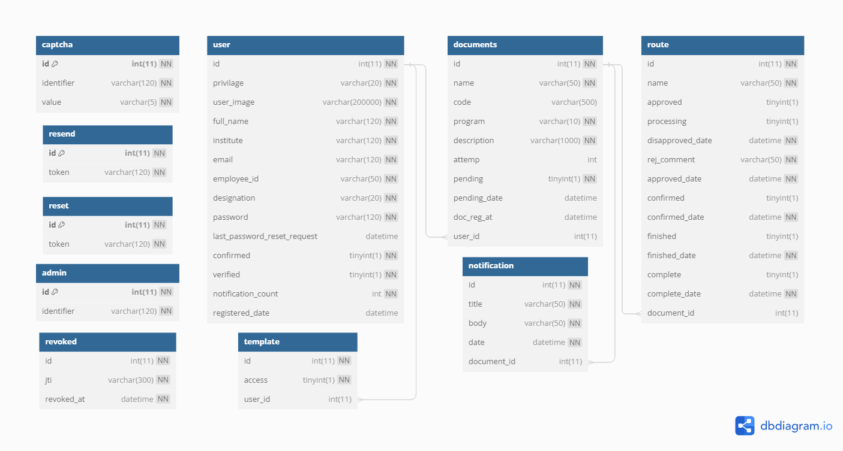Figure 3.4: DOCUTRACKER Entity Relationship Diagram

**3.5.3 Data Dictionary**

|  |  |  |  |  |
| --- | --- | --- | --- | --- |
| **Table Name** | **Attribute_Name** | **Type** | **Content** | **Format** |
| **Captcha** | id | Int (11) | Captcha Id | PK, not null |
| identifier | Varchar (120) | Captcha Identifier | Not null |
| capt_value | Varchat (5) | Captcha value | Not null |
| **Documents** | docu_id | Int (11) | Id | PK, not null |
| name | Varchar (50) | Document Name | Not null |
| code | Varchar (50) | Document QR Code | Null |
| program | Varchar (10) | Program Associated with the Document | Null |
| description | Varchar (200) | Document Description | Null |
| institute | Varchar(10) | Institute Associated with the Document | Null |
| attemp | Int(11) | Document Resubmit attemps | [default: 0] |
| pending | Tinyint(1) | Document Pending State | [default: true] |
| pending_date | datetime | Document Registered Date | datetime |
| user_id | Int(11) | User id | FK, Not null |
| **Notifications** | id | Int (11) | Notification id | PK, not null |
| title | Varchar (50) | Notification Title | Not null |
| body | Varchar(50) | Notification Content | Not null |
| date | datetime | Notification Date | Not null |
| document_id | Int(11) | Document Id | FK, not null |
| **Resend** | id | Int (11) | Resend Id | PK, not null |
| token | Varchar (120) | Token | Not null |
| **Reset** | id | Int (11) | Reset Id | PK, not null (000) |
| token | Varchar (120) | Reset Token | Not null |
| **Revoked** | id | Int (11) | Id | Not null |
| jti | Varchar (50) | Revoked Token Value | Not null |
| revoked_at | datetime | Revoke time | Not null |
| **Route** | id | Int (11) | Route Id | PK, not null |
| name | Varchar (50) | Name | Not null |
| approved | Tinyint (1) | Approved State | [default: 0] |
| disapproved_date | datetime | Disapprove Date | Null |
| rej_comment | Varchar (50) | Comment of rejection | Null |
| approved_date | datetime | Approve Date | Null |
| confirmed | Tinyint (1) | Confirmed State | [default: 0] |
| confirmed_date | datetime | Confirmed Date | Null |
| finished | Tinyint(1) | Finished State | [default: 0] |
| finished_date | datetime | Finished Date | null |
| complete | Tinyint(1) | Complete State | [default: 0] |
| complete_date | datetime | Complete Date | null |
| document_id | Int (11) | Document Id | FK, not null |
| **Template** | id | Int (11) | Template Id | Not null |
| access | Tinyint (1) | Access State | Not null |
| user_id | Int (11) | User id | FK, not null |
| **User** | id | Int(11) | User Id | PK, Not null |
| privilage | Varchar (20) | User privilage | Not null |
| user_img | Varchar (120) | User Image | Not null |
| full_name | Varchar (50) | User full name | Not null |
| institute | Varchar (120) | User Institute | Not null |
| email | Varchar (120) | User Email | Not null |
| Employee_id | Varchar (50) | User Employee Id | Not null |
| designation | Varchar (20) | User Designation | Not null |
| program | Varchar (20) | User Program | Not null |
| password | Varchar (120) | User password | Not null |
| last_password_reset_request | datetime | Last request date | [default: null] |
| confirmed | Tinyint(0) | User confirmed State | [default: 0] |
| verified | Tinyint(0) | User verified State | [default: 0] |
| notification_count | Int (11) | Notification Count | Not null |
| registered_date | datetime | User Registered Date | Not null |

Table 3.7: Data Dictionary

**3.5.4 Graphical User Interface Design**

This would display a potential mock-up of the web-based application that the developers intended to create.

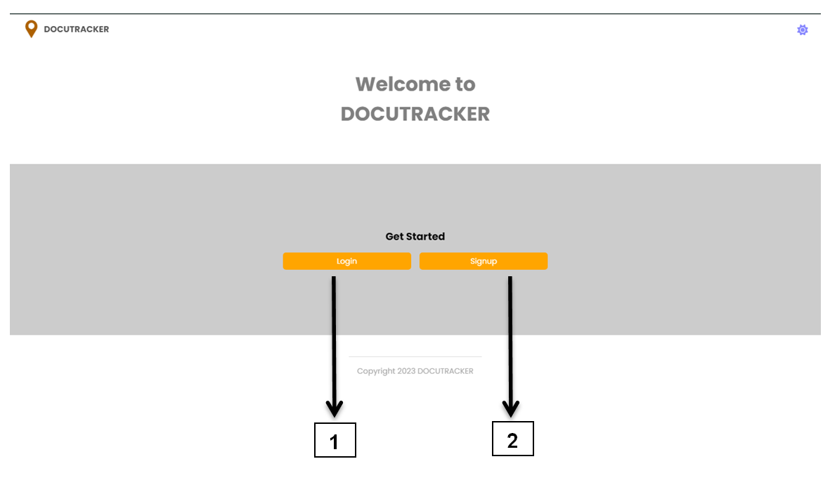

Figure 3.5: User and Secretary interface of DOCUTRACKER

Table 3.8: Overview Function Definition

|  |  |
| --- | --- |
| **Name** | **Function** |
| 1. Login button | Allows the user to access the login form. |
|  |  |
| 1. Reister button | Allows the user to access the signup form. |

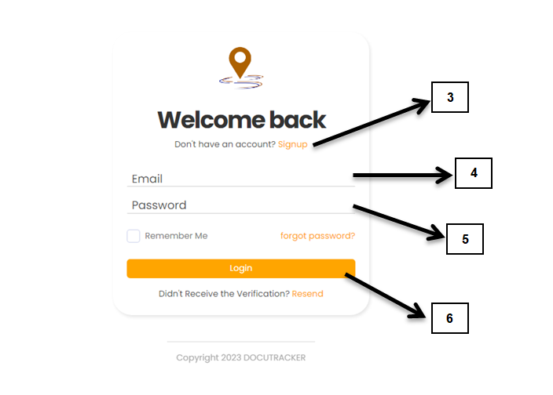

Figure 3.6: Login Form

|  |  |
| --- | --- |
| **Name** | **Functions** |
| 1. Signup hyperlink | Directs the user to access the signup form |
| 1. Email | Allows the user/secretary to enter a email |
| 1. Password | Allows the user/secretary to enter a password |
| 1. Login Button | Directs the user/secretary to dashboard page |

Table 3.9: Login Function Definition

Figure 3.7: Sign up form

|  |  |
| --- | --- |
| **Name** | **Functions** |
| 1. Registration credentials | Allows the user to enter the credentials of account. |
| 1. Dropdowns | Allows the user to select designation (Secretary, Faculty, Program Head, Dean Office, Academic VP, OP) and institute. |
| 1. Captcha | Validates the user to if not a robot through captcha |
| 1. Upload profile | Allows the user to upload his/her profile picture. |
| 1. Submit button | Directs the user/receiver to login form. |

Table 3.10: Signup Function Definition

**User Interface**

Figure 3.8: User Dashboard

|  |  |
| --- | --- |
| **Name** | **Functions** |
| 1. Sidebar Navigation | Contains a group of navigations |
| 1. Add/Register Document | Directs the user to request document |
| 1. Scan Document | Directs the user for scanning of documents. |
| 1. Registration status | Provides information details for the status of document registration. |
| 1. Registration status widget | Displays the quantity of registered document based on its status whether it is to be forwarded, approved, for waiting, complete, and rejected. |
| 1. Document registration details | Displays the table list of registered documents which includes document name, description, ID, and registered date |

Table 3.10: Dashboard Function Definition

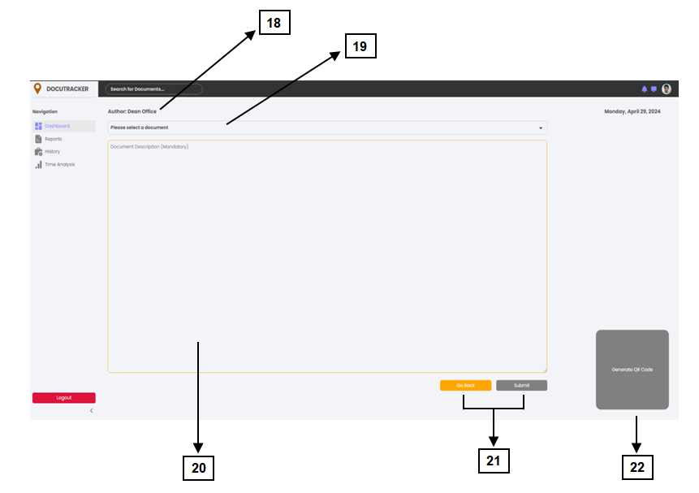

Figure 3.9: User Dashboard/Register Document

|  |  |
| --- | --- |
| **Name** | **Functions** |
| 1. Designation | Displays the work designation of the user |
| 1. Select Document | Allows the user to select a document to be registered, Predefined or Custom |
| 1. Document Description | User is required to include an description that is associated to the selected document |
| 1. Back and Submit Button | Once the user is done, clicking submit will able to send his/her request to be processed. Pressing back button will directs back to dashboard. |
| 1. Generate QR code | Allows the user to generate a QR code that will be used for the identification of selected document |

Table 3.11: Document Registration Function Definition

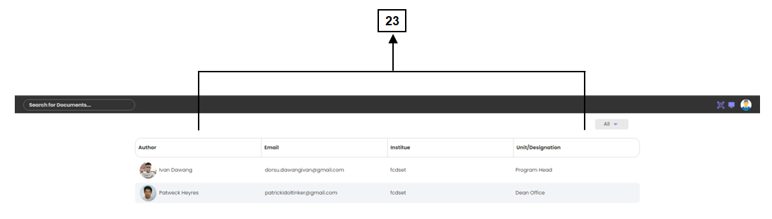**Secretary Interface**

Figure 3.10: Secretary Dashboard

|  |  |
| --- | --- |
| **Name** | **Functions** |
| 1. User account details | Displays the table list of users who requests a document. |

Table 3.12: Secretary Dashboard Function Definition

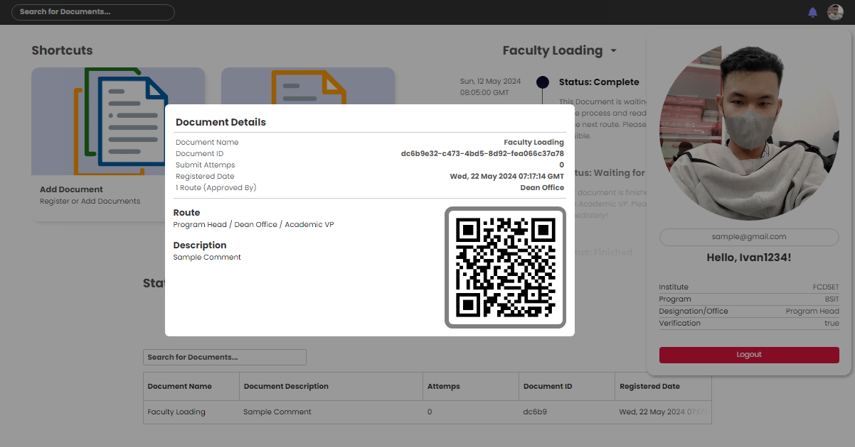

Figure 3.11: Document registration details

Figure 3.18: Registered Account List

This figure shows the details of the registered document (once clicked the user’s info shown in figure 3.11) that is made by the user. It contains the name, email, document name, ID, registered date, document description and its route.

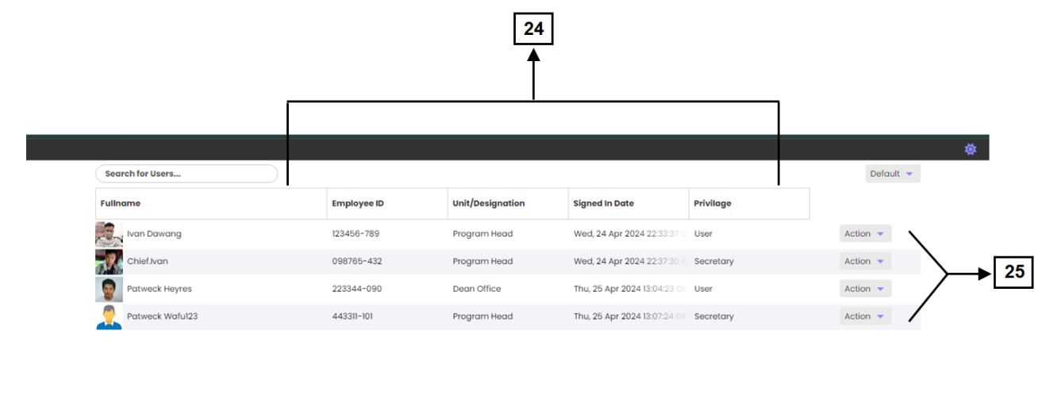**Admin Interface**

Figure 3.12: Admin Dashboard

|  |  |
| --- | --- |
| **Name** | **Functions** |
| 1. User account details | Displays the user’s information and its privilege to the system. |
| 1. Privilege selection | Allows the admin to set a privilege to the users after they’ve register account. Has two privilege which is user or document receiver. |

Table 3.13: Admin Dashboard Function Definition

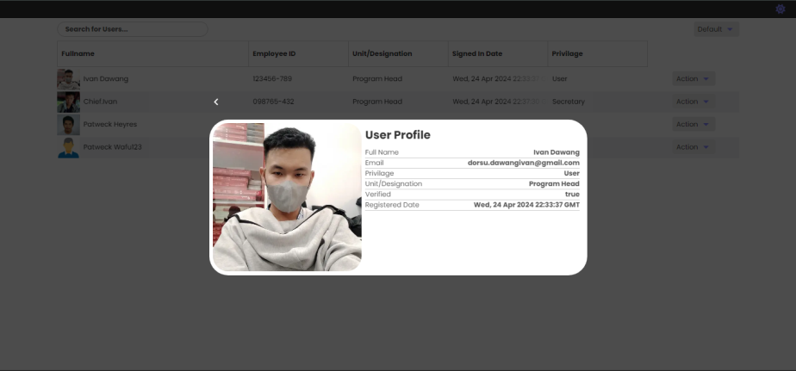

Figure 3.13: Admin Dashboard/User Profile

This figure shows the credentials of the user. It contains the name of the user, email, privilege to the system, designation, and date of registration.

**3.6 Development and Testing**

* + 1. **Development**

During the DOCUTRACKER development phase, the developers used a combination of HTML/CSS, svelte, and flask to create the user interface, creating an engaging and responsive design for the website. Front-end development was carried out utilizing these web technologies to provide consumers with a visually pleasing experience. The developers used PHP in combination with XAMPP as the server environment and MySQL as the database management system for the backend.

Visual Studio Code was the primary coding environment utilized throughout the development process. The compatibility, performance, and adaptability of these technologies influenced their selection, which contributed to the overall development of the DOCUTRACKER website.

* + 1. **Data Analysis plan**

The DOCUTRACKER project, a web-based document tracker for Davao Oriental State University, will be reviewed by the ISO 25010:2011 standard to see if it fits the criteria. This assessment will be based on the evaluation of each user. DOCUTRACKER was evaluated using a questionnaire based on the ISO25010:2011 paradigm. Indicators for functional appropriateness, performance efficiency, usability, dependability, security, maintainability, and portability are included in the questionnaire.

The data will be analyzed using Weighted Arithmetic Mean for the evaluation. The respondents' answers on the survey may produce the Likert scale. Each assessment item will be graded on a scale of 1 to 5, with 5 indicating strong agreement and 1 indicating strong disagreement. The weighted arithmetic mean will be obtained for each item, and the overall score of evaluation will be generated by averaging the responses of every item.

The weighted arithmetic mean will be interpreted using the scale below:

|  |  |
| --- | --- |
| Weighted arithmetic mean range | Interpretation |
| 4.50 – 5.0 | Strongly Agree |
| 3.50 – 4.50 | Agree |
| 2.50 – 3.50 | Undecided/Fair |
| 1.50 – 2.50 | Disagree |
| 1.50 and below | Strongly Disagree |

**CHAPTER IV**

**RESULTS AND DISCUSSION**

**4.1 Achievements per objective**

The DOCUTRACKER successfully facilitates the registration of documents, incorporating a QR code generation feature. This function enables quick identification and easy retrieval of files, significantly reducing the time spent searching for documents. The QR codes serve as a unique identifier for each document, ensuring that they are easily trackable and minimizing the risk of misplacement.

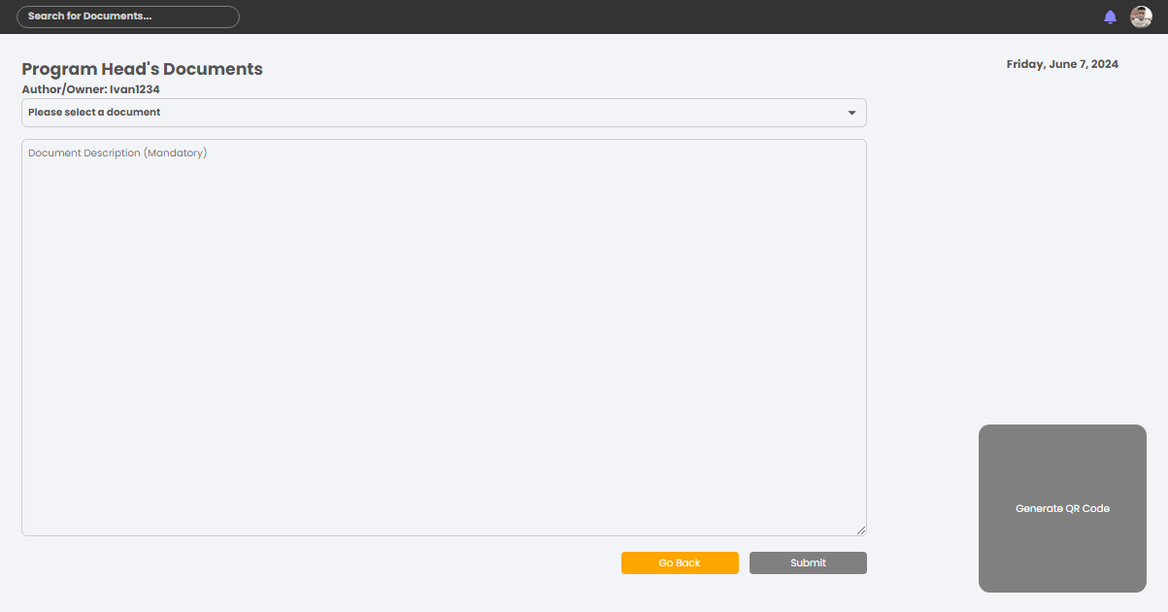

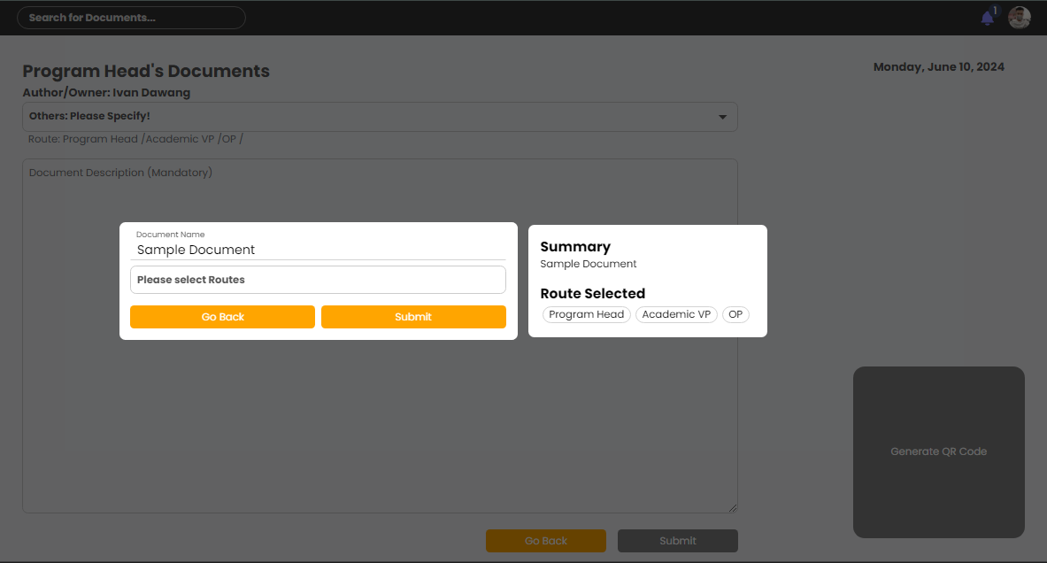

Figure 4.1: Document Registration Interface

The system provides users with real-time updates on the status of documents throughout their lifecycle. Users can view the current status and the time taken at each stage of document processing, which helps in identifying bottlenecks and improving overall efficiency. The visual representation of the document's journey ensures that all stakeholders are aware of its progress, enhancing transparency and accountability within the organization.

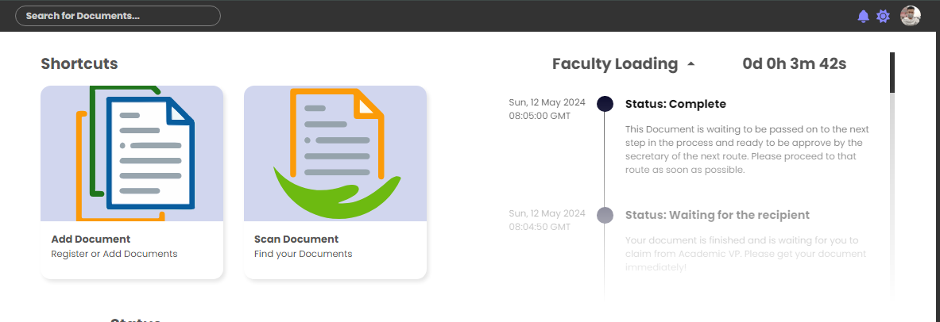

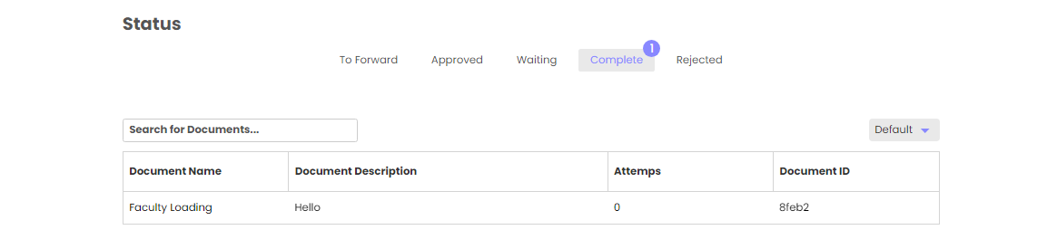

Figure 4.2: User Dashboard

DOCUTRACKER includes a comprehensive time analysis feature that breaks down the time spent on each stage of document processing. This analysis allows users to pinpoint areas where delays occur and implement strategies for improvement.

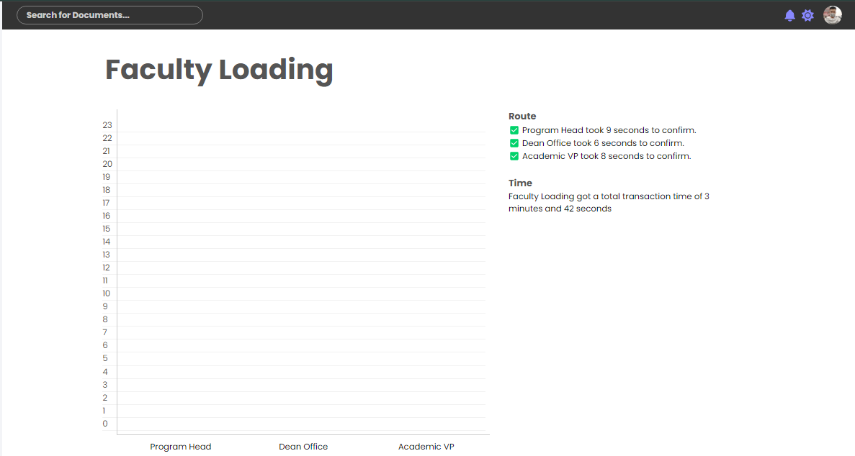

Figure 4.3: Time Analysis

Additionally, the system enables users to download a PDF file of the document's data for offline viewing, ensuring that information is accessible even without an internet connection. This feature is particularly useful for reporting and auditing purposes.

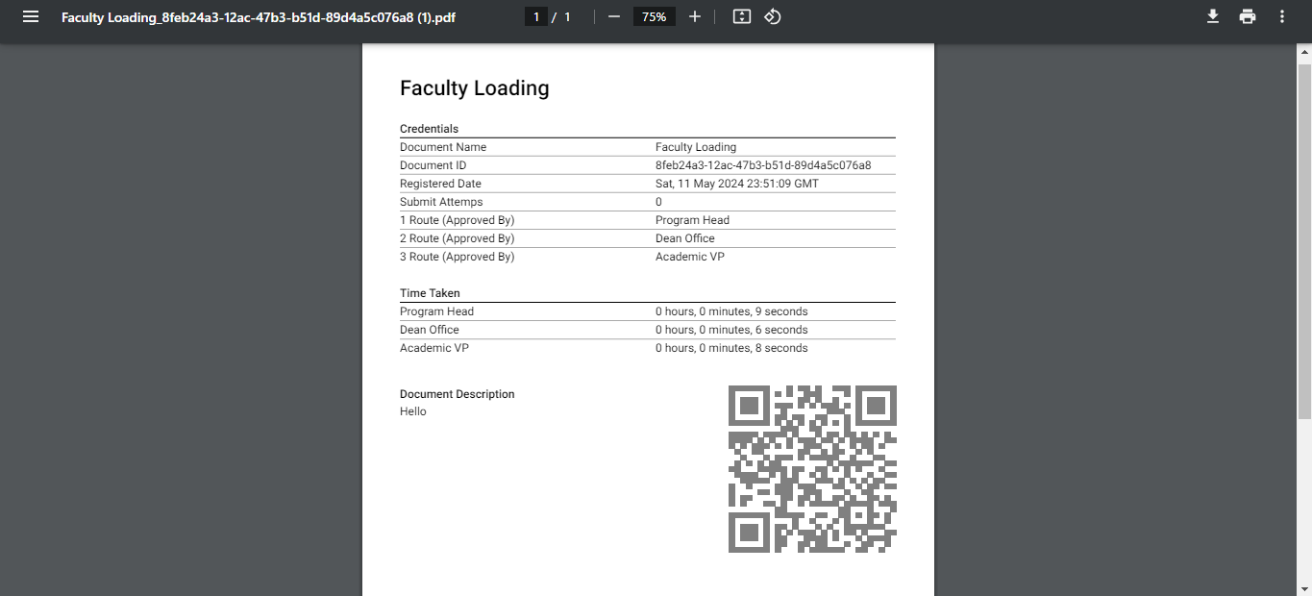

Figure 4.4: Offline Data

**4.2 Implication and Result Discussion**

The implementation of DOCUTRACKER has shown significant improvements in the management and organization of documents at Davao Oriental State University. By providing an intuitive interface and streamlining the document lifecycle from creation to retrieval, the system has enhanced operational efficiency. The platform's secure and accessible nature promotes a smooth flow of information between departments, thereby fostering a more responsive administrative process.

Furthermore, the system not only encourages transparency and accountability but also significantly reduces the time and effort required for document handling. This efficiency gain translates into better resource allocation and improved administrative services within the university. The implementation of DOCUTRACKER exemplifies how modern technology can be leveraged to address traditional challenges in document management, resulting in significant operational benefits for the institution.

**4.3 Implementation Plan**

In preparing for the rollout of the system, we have crafted a comprehensive implementation plan. This strategic blueprint is designed to ensure a smooth transition and successful adoption of the system across our target areas. Collaborating closely with key stakeholders, we aim to identify optimal sites and beneficiaries who will greatly benefit from this initiative. Our strategy is outlined in detail in Table 4.1, serving as a roadmap for the systematic deployment of our project.

|  |  |  |  |
| --- | --- | --- | --- |
| **STRATEGY** | **ACTIVITIES** | **PERSONS INVOLVED** | **DURATION** |
| Approval From Users | Letter | Researcher, Users | 1 Day |
| Deployment | Installation of the System’s Dependencies and Libraries | Researchers | 30 Minutes |
| Information Distribution | User Manual | Researcher, Users | 1 Day |

Table 4.1: Implementation Plan

**CHAPTER V**

**SUMMARY, CONCLUSIONS AND RECCOMENDATIONS**

**5.1 Summary**

Researchers developed, designed, and implemented a web-based document management information system for Davao Oriental State University that is capable of adapting the manual processing method of documents within faculties in DOrSU to reduce given time and effort of those who process and manage the documents. The researchers gathered information on mainly processed documents and their routes to be applied in the system. For the system development, the researchers developed a design plan that focuses on a user-friendly interface and uses some programming language for the overall functionality of the system.

**5.2 Conclusion**

In conclusion, the developers of DOCUTRACKER, a web-based document management information system established at Davao Oriental State University, have provided an essential solution for managing and organizing the university's arrays of papers. This system features an easy-to-use interface that streamlines the document lifecycle, from creation to retrieval. DOCUTRACKER not only fosters transparency and accountability but also reduces the time and effort required to handle documents. Its secure and accessible platform ensures a smooth flow of information between departments, resulting in a more efficient and responsive administrative process for Davao Oriental State University.

**5.3 Recommendation**

In light of the evolving needs and challenges faced by Institution in managing document workflow efficiently, we propose a series of recommendations aimed at optimizing the current system. These improvements are designed to streamline processes, enhance accountability, and ensure inclusivity across different roles involved in document handling. By implementing these changes, we aim to foster a more transparent, secure, and effective document management environment.

* Re-design the system process flow in document tracking
* Include other person involved in document processing not only the secretary of the institute/office/unit.
* Demonstrate at least three document types that is being forwarded from & to (ex. Dean/ VPAA/ OP)
* There should be a mechanism to approved what user type/role should the user/s belongs.
* If the program head is the uploader, it should be approved by itself
* Include a faculty account
* Include who is the Sender of the document in the document Registration Page

**Literature Cited**

Abba, I. V. (2022). What is an ORM – The Meaning of Object Relational Mapping Database Tools. freeCodeCamp.org. https://www.freecodecamp.org/news/what- is-an-orm-the-meaning-of-object-relational-mapping-database-tools/

About SQLite. (n.d.). https://www.sqlite.org/about.html

Aiim. (n.d.). What is Document Management (DMS)? https://www.aiim.org/What-Is Document-Imaging

BenTech. (n.d.). Common Document Management Problems & how to avoid them? www.linkedin.com. https://www.linkedin.com/pulse/common-document- management-problems-how-avoid-them-venkat-bentech

Bestaieva, D., & Altynpara, E. (2023, August 8). The full guide on Agile SDLC for 2023. Cleveroad Inc. - Web and App development company. https://www.cleveroad.com/blog/agile-sdlc/

Canva Graphic Design Company 2023 | Agile Methodology. https://www.canva.com/design/DAFr6Vgwt9Y/6dScH0kXTAgmpWyvn0s-dw/edit

Chen, X. (2005). The Interrelationship between Document Management, Information Management and Knowledge Management. https://uir.unisa.ac.za/handle/10500/13666

Chehab, G., & Chehab, G. (2023). What is an ORM? how does it work? How should we use one? | Baeldung on Computer Science. Baeldung on Computer Science. https://www.baeldung.com/cs/object-relational-mapping

Clark, J. (2023). Top 10 advantages of Firebase. Back4App Blog https://blog.back4app.com/advantages-of-firebase/

Corporation, D. (n.d.). What is Document Management (DMS)? | DocuWare. https://start.docuware.com/document-management

Costoiu, M., Plesu, V., Isopescu, R., Soriga, S. G., Alesincu, S. H., & Arsene, I. C. (2019). Electronic Document Management Information System for Universities. Chemical Engineering Transactions, 29, 1639–1644. https://doi.org/10.3303/cet1229274

Côrtes, P. L., & De Paula Côrtes, E. G. (2020). Hospital information systems: a study of electronic patient records. Jistem Journal of Information Systems and Technology Management, 8(1), 131–154. https://doi.org/10.1590/s1807- 17752011000100008

Document Tracking System | Document Management Software. (2022). GigaTrak. https://www.gigatrak.com/software/document-tracking-system/

Dyouri, A. (2022). How To Make a Web Application Using Flask in Python 3. DigitalOcean. https://www.digitalocean.com/community/tutorials/how-to-make-a- web-application-using-flask-in-python-3

Emralino, J. B. (2019). PROJECT DOTS (DOCUMENT TRACKING SYSTEM): ITS EFFECTS IN THE INTER-OFFICES IN THE SCHOOLS DIVISION OF PARAÑAQUE CITY. https://ejournals.ph/article.php?id=14080

GeeksforGeeks. (2021). Firebase Introduction. GeeksforGeeks. https://www.geeksforgeeks.org/firebase-introduction/

Getting started with Svelte - Learn web development | MDN. (2023). https://developer.mozilla.org/en- US/docs/Learn/Tools_and_testing/Client_side_JavaScript_frameworks/Svelte_ge tting_started

GLOBODOX. (2023). Document Management System (DMS) - GLOBODOX. https://www.globodox.com/

GLODOBOX Document Management Software (2023). globodox- https://www.globodox.com/globodox-features/use-with-ease/

Gigatrak Document Tracking System (2022). https://www.gigatrak.com/software/document-tracking-system/

Han, J. W., Wang, C., Miao, J., Lu, M., Wang, Y., & Shi, J. (2021). Research on Electronic Document Management System based on Cloud Computing. Computers, Materials & Continua, 66(3), 2645–2654. https://doi.org/10.32604/cmc.2021.014371

Hanna, K. T., & Rosencrance, L. (2023). Google Firebase. Mobile Computing. https://www.techtarget.com/searchmobilecomputing/definition/Google-Firebase

Hawthorne, J. (2023). The benefits of a centralized document management system for global enterprises. Document Management System Folderit. https://www.folderit.com/blog/the-benefits-of-a-centralized-document- management-system-for-global-enterprises/

Haryawan, C., & Iswanti, S. (2021). IMPLEMENTASI PIECES FRAMEWORK DALAM PERANCANGAN E-DOCUMENT MANAGEMENT SYSTEM WEBSITE PUSAT JAMINAN MUTU. Jurnal Teknik Informasi Dan Komputer, 4(2), 137. https://doi.org/10.37600/tekinkom.v4i2.344

Ian. (2021, June 20). What does ACID mean in Database Systems? https://database.guide/what-is-acid-in-databases/

iNetTutor.com. (2022, November 15). Document Control System Conceptual Framework - iNetTutor.com. iNetTutor.com. https://www.inettutor.com/diagrams/document- control-ipo-conceptual/

Inc, T. (2023). What is Agile [Guide] | Trundl. Trundl | Atlassian Solution Platinum Partner. https://trundl.com/resources/guides/what-is-agile/#What_is_Agile

Kiplie, F. H., Yatin, S. F. M., Angutim, M., & Hamid, N. H. A. (2018). System development for Document Management system. International Journal of Academic Research in Business & Social Sciences. https://doi.org/10.6007/ijarbss/v8-i9/4652

Labis, X. (2023). What are Document Tracking Systems? Syntactics Inc. https://www.syntacticsinc.com/news-articles-cat/document-tracking-systems/

Labis, X. (2023b, July 26). What are Document Tracking Systems? Syntactics Inc. https://www.syntacticsinc.com/news-articles-cat/document-tracking-systems/

Lori. (2018, November 14). Records Management Literature: the language of collaboration - Lori Birrell. Lori Birrell. http://lori.birrell.us/2010/11/14/records- management-literature-the-language-of-collaboration/

Luna-Reyes, L. F., & Gil-Garcia, J. R. (2019). Digital government transformation and internet portals: The co-evolution of technology, organizations, and institutions. Government Information Quarterly, 31(4), 545–555. https://doi.org/10.1016/j.giq.2014.08.001

M-Files. (2021, October 5). Document management system | M-Files. M-Files | the Smarter Way to Work. https://www.m-files.com/supplemental/document- management-system/

M-Files: Digital Document Management (2022). https://www.google.com/url?sa=i&url=https%3A%2F%2Fwww.m-files.com%2Fm- filesplatform

Murphy, D. (2022). The importance of information systems security. https://iticollege.edu/blog/the-importance-of-information-systems-security/

Nakajima, S. M. (2021). Beginner’s guide to Svelte - From basics to state management and animation. Twilio Blog. https://www.twilio.com/blog/all-you-need-to-know- svelte

Omisola, I. (2021). What is Google Firebase and why should you use it? MUO. https://www.makeuseof.com/what-is-google-firebase-why-use-it/

Ontra. (2023). 7 benefits of a document management system. Ontra. https://www.ontra.ai/blog/benefits-modern-document-management-systems-dms/

ORM or SQL in large, scalable and MAINTAINABLE web application? (n.d.). Stack Overflow. https://stackoverflow.com/questions/2637259/orm-or-sql-in-large- scalable-and-maintainable-web-application

Paikroy, P. (2023, July 9). Understanding MVC architecture: Building robust and maintainable applications. Piyush Paikroy. http://piyushpaikroy.hashnode.dev/understanding-mvc-architecture-building- robust-and-maintainable-applications

S, R. A. (2023). What is SQLite? Everything You Need to Know. Simplilearn.com. https://www.simplilearn.com/tutorials/sql-tutorial/what-is-sqlite

Team, M. (2023). 11 Benefits and Advantages of document management systems. MHC Automation. https://www.mhcautomation.com/blog/11-benefits-and-advantages- of-document-management-systems/

Techopedia. (2022, August 9). What is an Electronic Document Management System (EDMS)? - Definition from Techopedia. https://www.techopedia.com/definition/12769/electronic-document-management- system-edms

The UP Document Tracking System (DTS) | University of the Philippines Information Technology Development Center. (n.d.). https://itdc.up.edu.ph/news/the-up- document-tracking-system-dts

Uzondu, D. (2023). What is Svelte Framework and how do you use it? MUO. https://www.makeuseof.com/what-is-svelte-framework-and-how-do-you-use-it/

What is a document tracking service? (n.d.). business.com. https://www.business.com/articles/document-tracking/

Xiao, X. (2022). Research and application of Cloud Platform-Oriented Intelligent Information Management System. Wireless Communications and Mobile Computing, 2022, 1–8. https://doi.org/10.1155/2022/8397780

Zammit, I. (2023). Document Management System Definition. Document Management System Folderit. https://www.folderit.com/blog/document-management-system- definition/